Ansible Task 3
- Write a single ansible playbook which will install apache and nginx. Note: Playbook should not be hardcoded and pass the variables from different file.
- Ansible playbook to create 10 different directories with minimal code and directory names should be passed as variables.
- Ansible playbook to copy ssh-keygen from master to worker nodes. Note: a)Provision new 3 ec2 machines, one master and two worker nodes. b)Create common user called ansadm and provide sudo priviliges on 3 ec2 instances. c)Create ssh-keygen in master and your playbook should copy the keygen making it password less authentication.
- Ansible playbook to inject ansible vault variables.
- Step 1 — Create the variables file
- On your Ansible master, run:
- cd ~/ansible-lab
- nano webservers_vars.yml
- Paste this complete content:
- ---
- webserver_packages:
- - apache2
- - nginx

- webserver_state: present

- Step 2 — Create install_webservers.yml
- Run this command on your Ansible master:
- nano ~/ansible-lab/install_webservers.yml
- Paste this complete playbook:
- ---
- - name: Install Apache and Nginx using external variables
- hosts: workers
- become: true
- gather_facts: false

- vars_files:
- - webservers_vars.yml

- tasks:
- - name: Install web server packages
- ansible.builtin.apt:
- name: "{{ webserver_packages }}"
- state: "{{ webserver_state }}"
- update_cache: true

- - name: Start and enable web servers
- ansible.builtin.service:
- name: "{{ item }}"
- state: started
- enabled: true
- loop: "{{ webserver_packages }}"
- Step 2 — Run the playbook
- cd ~/ansible-lab
- ansible-playbook -i ansible_hosts install_webservers.yml

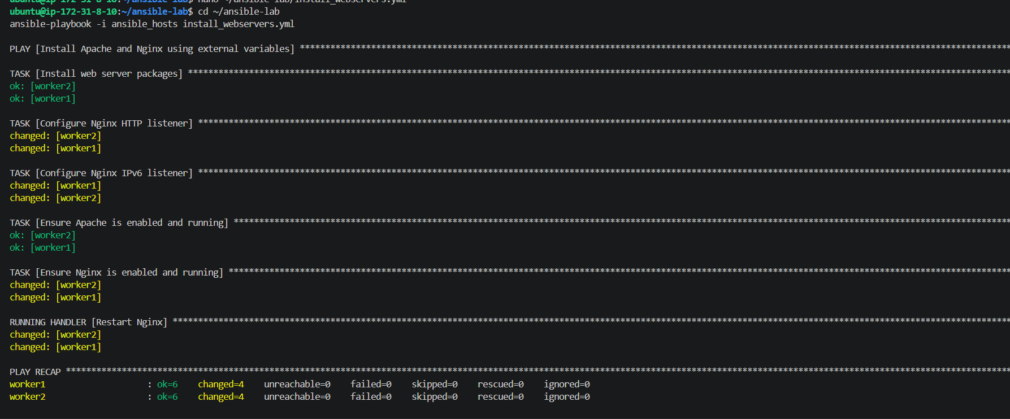
Final verification
Run this command to verify all three services:
ansible workers -i ansible_hosts -b -m shell -a "systemctl is-active apache2 nginx tomcat10"
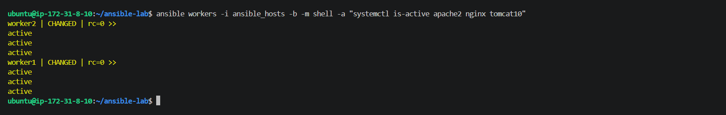
2. Create 10 directories using variables
We'll use a separate variables file containing the directory names and one playbook with a loop to create all ten directories.
Step 1 — Create the variables file
Run this command on your Ansible master:
cd ~/ansible-lab
nano directories_vars.yml
Paste this complete content:
---
directory_names:
- /opt/ansible/dir1
- /opt/ansible/dir2
- /opt/ansible/dir3
- /opt/ansible/dir4
- /opt/ansible/dir5
- /opt/ansible/dir6
- /opt/ansible/dir7
- /opt/ansible/dir8
- /opt/ansible/dir9
- /opt/ansible/dir10
Step 2 — Create create_directories.yml
Run this command on your Ansible master:
nano ~/ansible-lab/create_directories.yml
Paste this complete playbook:
---
- name: Create ten directories using external variables
hosts: workers
become: true
gather_facts: false

vars_files:
- directories_vars.yml

tasks:
- name: Create directories
ansible.builtin.file:
path: "{{ item }}"
state: directory
mode: '0755'
loop: "{{ directory_names }}"
Step 3 — Validate the syntax
cd ~/ansible-lab
ansible-playbook -i ansible_hosts --syntax-check create_directories.yml
If the syntax check passes, run it:
ansible-playbook -i ansible_hosts create_directories.yml
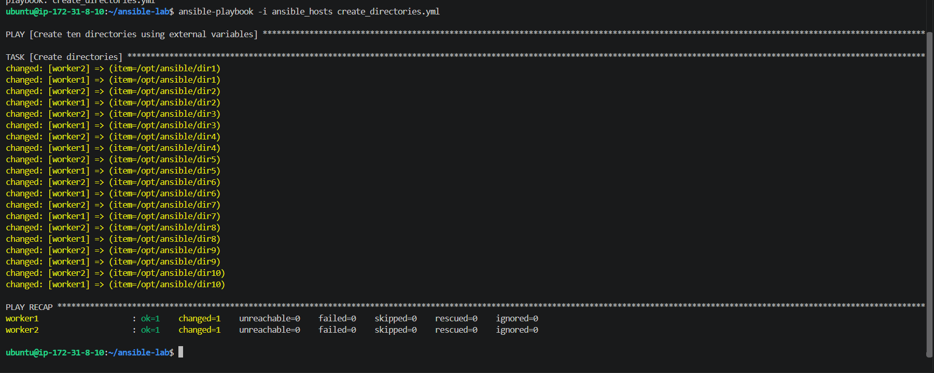
3 . Configure passwordless SSH using Ansible
Step 1 — Confirm your EC2 setup
Before provisioning the three instances, let's check whether you already have any suitable EC2 instances for this assignment.
Run this on your Ansible master:
aws ec2 describe-instances \
--region ap-south-1 \
--filters "Name=instance-state-name,Values=running" \
--query "Reservations[].Instances[].{Name:Tags[?Key=='Name']|[0].Value,InstanceId:InstanceId,PrivateIP:PrivateIpAddress,PublicIP:PublicIpAddress}" \
--output table
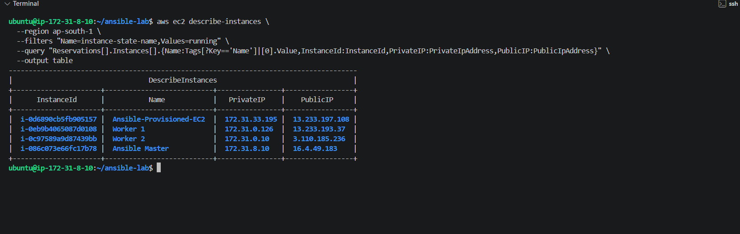
Step 2 — Check your EC2 security group and key pair
First, let's identify the existing key pair and security group settings we can use as a reference.
Run:
aws ec2 describe-instances \
--region ap-south-1 \
--instance-ids i-086c073e66fc17b78 \
--query "Reservations[0].Instances[0].{KeyName:KeyName,SecurityGroups:SecurityGroups[].GroupId,SubnetId:SubnetId,VpcId:VpcId}" \
--output table
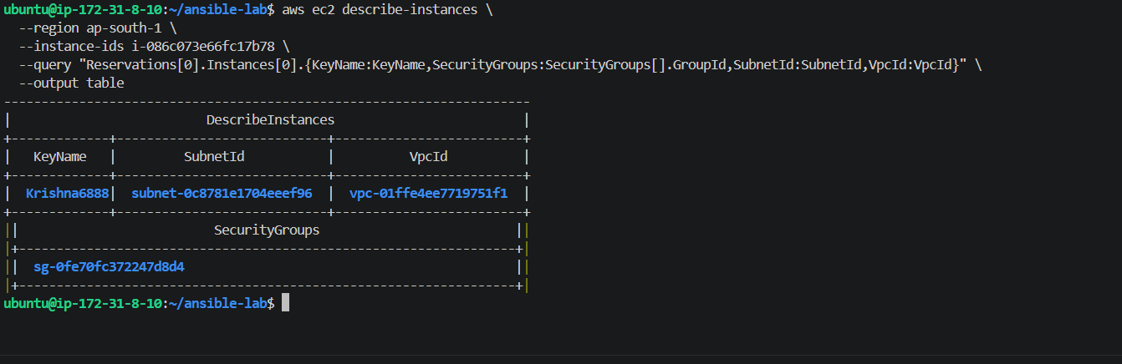
Step 3 — Check security group rules
Run this command on your Ansible master:
aws ec2 describe-security-groups \
--region ap-south-1 \
--group-ids sg-0fe70fc372247d8d4 \
--query "SecurityGroups[0].IpPermissions" \
--output table
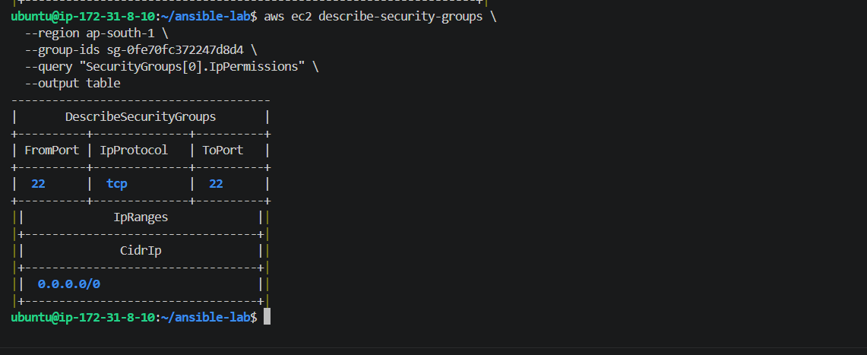
Step 4 — Create a dedicated security group
Run this command on your Ansible master:
aws ec2 create-security-group \
--region ap-south-1 \
--group-name ansible-ssh-lab-sg \
--description "SSH access for Ansible master and worker lab" \
--vpc-id vpc-01ffe4ee7719751f1
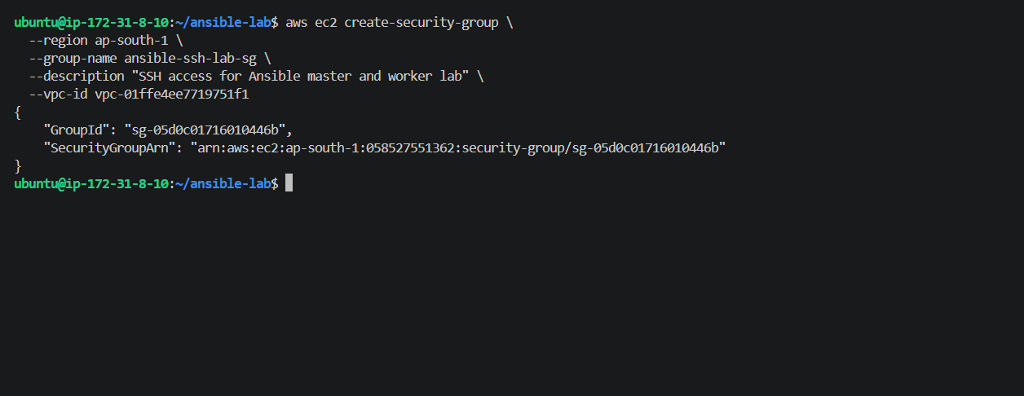
Step 5 — Allow SSH between the new instances
We'll allow SSH from your existing Ansible master to the new instances, and allow SSH between instances inside the dedicated security group.
Run this command:
aws ec2 authorize-security-group-ingress \
--region ap-south-1 \
--group-id sg-05d0c01716010446b \
--protocol tcp \
--port 22 \
--source-group sg-05d0c01716010446b
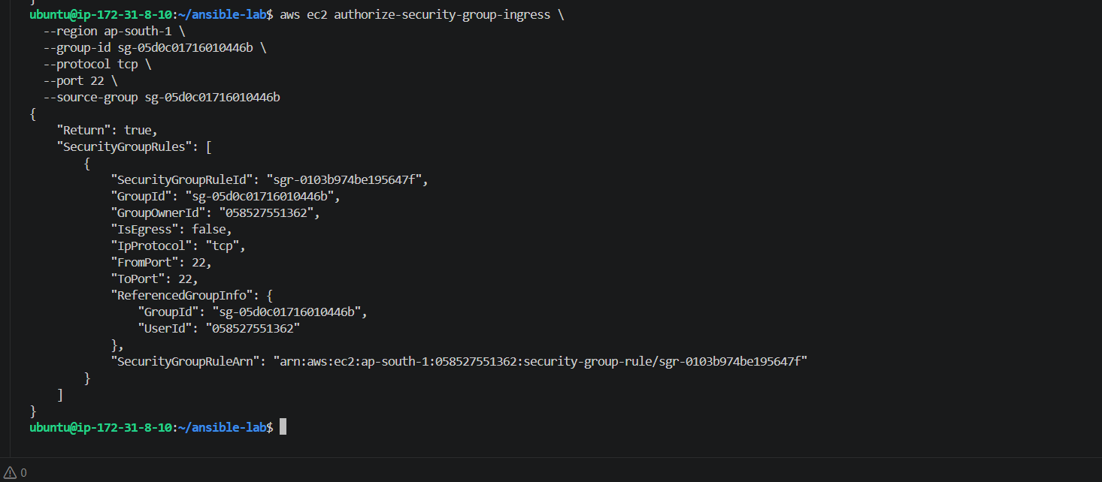
Step 6 — Allow SSH from your current Ansible master
Your existing Ansible master uses security group sg-0fe70fc372247d8d4. We'll allow that group to SSH into the new lab instances.
Run:
aws ec2 authorize-security-group-ingress \
--region ap-south-1 \
--group-id sg-05d0c01716010446b \
--protocol tcp \
--port 22 \
--source-group sg-0fe70fc372247d8d4
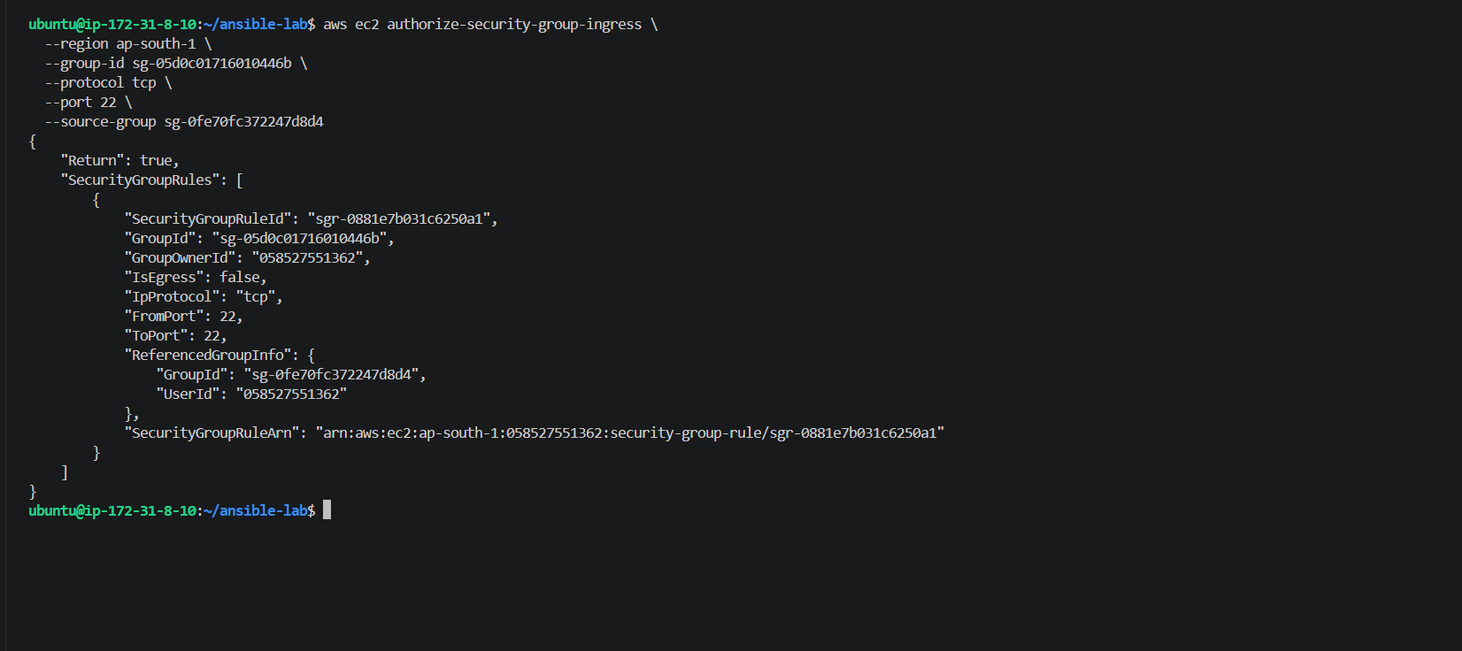
Step 7 — Launch 3 EC2 instances
We'll use the Ubuntu 24.04 AMI we found earlier, the existing Krishna6888 key pair, and the dedicated security group.
Run this command on your Ansible master:
aws ec2 run-instances \
--region ap-south-1 \
--image-id ami-094adff9b24048c5c \
--instance-type t3.micro \
--key-name Krishna6888 \
--security-group-ids sg-05d0c01716010446b \
--subnet-id subnet-0c8781e1704eeef96 \
--count 3 \
--tag-specifications 'ResourceType=instance,Tags=[{Key=Name,Value=Ansible-SSH-Lab}]' \
--query "Instances[].InstanceId" \
--output table
Fix the playbook
We'll make the public key readable by the ubuntu user without exposing or changing the private key.
Run this command on the master:
sudo chmod 644 /home/ansadm/.ssh/id_ed25519.pub
Now recreate copy_ssh_key.yml using the actual public key:
cat > copy_ssh_key.yml <<'EOF'
---
- name: Copy ansadm public SSH key to workers
hosts: workers
become: true
gather_facts: false

tasks:
- name: Add master public key to ansadm authorized keys
ansible.posix.authorized_key:
user: ansadm
key: "ssh-ed25519 AAAAC3NzaC1lZDI1NTE5AAAAIBzHD6I3PnnmWeHfxHD1Owqpo53YT7NRzT1yxhY1GR04 ansadm@ip-172-31-8-10"
state: present
EOF
Then run the playbook:
ansible-playbook -i ansible_hosts copy_ssh_key.yml
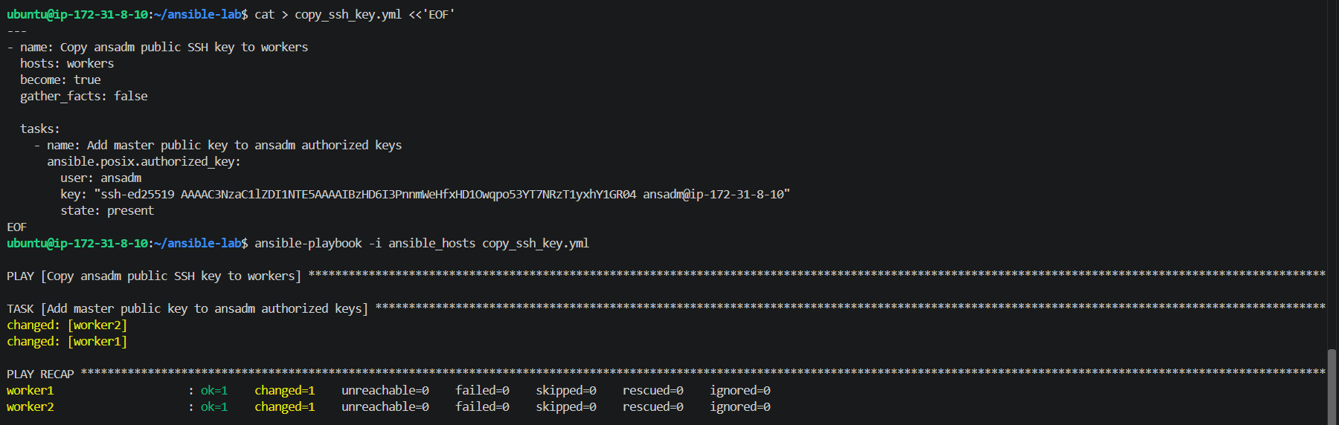

Test passwordless SSH
Now we'll verify that ansadm can connect from the master to each worker without entering a password.
Test worker1 — run this command on the master:
sudo -u ansadm ssh -i /home/ansadm/.ssh/id_ed25519 -o StrictHostKeyChecking=accept-new ansadm@172.31.0.126 'whoami'
Test worker2
Run this command on the master:
sudo -u ansadm ssh -i /home/ansadm/.ssh/id_ed25519 -o StrictHostKeyChecking=accept-new ansadm@172.31.0.10 'whoami'
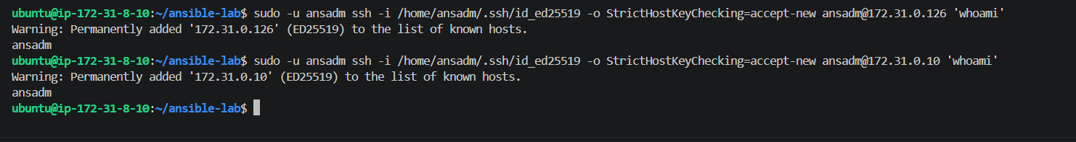
4 — Inject Ansible Vault variables
Ansible Vault lets you encrypt sensitive information, such as database passwords and API keys, so secrets aren't stored as readable plain text.
Step 1 — Create a variables file
On your Ansible master, inside ~/ansible-lab, run:
cd ~/ansible-lab
Then create the file:
cat > vault_vars.yml <<'EOF'
---
app_user: demoapp
db_password: "LabSecret123!"
EOF
Step 2: Encrypt the variables file
Now we'll encrypt vault_vars.yml using Ansible Vault so the database password is no longer visible as plain text.
Run this command on your Ansible master:
ansible-vault encrypt vault_vars.yml
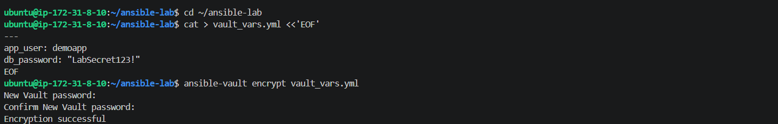
Step 3 — Create the Vault variables playbook
On your Ansible master, run this command inside ~/ansible-lab:
cat > vault_demo.yml <<'EOF'
---
- name: Inject Ansible Vault variables
hosts: workers
become: true
gather_facts: false

vars_files:
- vault_vars.yml

tasks:
- name: Display application username
ansible.builtin.debug:
msg: "Application user is {{ app_user }}"

- name: Verify database password is loaded without displaying it
ansible.builtin.assert:
that:
- db_password is defined
- db_password | length > 0
success_msg: "Database password loaded successfully from Ansible Vault."
EOF
Step 1 — Check the Vault file encryption
Run:
head -n 1 vault_vars.yml
If it displays something like:
$ANSIBLE_VAULT;1.1;AES256
your file is encrypted successfully.
Step 2 — Run the syntax check with your Vault password
Use:
ansible-playbook -i ansible_hosts --syntax-check --ask-vault-pass vault_demo.yml
Step 4 — Run the Vault playbook
Run this command on your Ansible master:
ansible-playbook -i ansible_hosts --ask-vault-pass vault_demo.yml
